User Guide

Based on the v1.3 firmware

Table of contents
- Introduction 2
- User interface 3
Main screen 3
Menu screen 5
Keypad screen 6
Device settings 7
- Performing measurements 9
Setting the measurement frequency range 9
Calibration 10
Trace display 11
Markers 13
Time domain operation 14
Recall calibration and settings 17
Saving measurement data with a MicroSD card 18
- NanoVNA-APP Software 19
User interface 19
Use Zadig to install the USB-CDC driver 22
- Appendix– USB data interface 23
Protocol description 23
Host to device command list 24
Register descriptions 25
Register descriptions (DFU mode) 27

Introduction
Thank you for your trust and choosing LiteVNA. LiteVNA builds on the widely acclaimed NanoVNA and SAA2. Now you can get a portable VNA that is as small as the NanoVNA and capable of ultra-wide range measurements from 50 kHz to 6 GHz.
In order to minimize power consumption and size, LiteVNA uses only one mixer, which allows S11 and S21 measurements through internal RF switching and can allows TDR and DTF measurements through IFFT calculations.
The preparation of this manual refers to the NanoVNA User Guide of cho45.

LiteVNA Specifications

Parameter | Specification | Conditions
Frequency range | 50kHz ~ 6.3GHz | -
System dynamic range | >70dB  >90dB(v0.3.1 20avg) | f < 3GHz, calibrated
 | >50dB | f >= 3GHz, calibrated
S11 noise floor | <-50dB | f <3GHz, calibrated
 | <-40dB | f >= 3GHz, calibrated
Frequency stability | <0.5ppm | 0℃ - 50℃
Sweep rate | >550 points/s | Avg=1
Sweep points (on device) | 21 ~ 1001 points, adjustable | -
Sweep points (USB) | 1 ~ 65535 points, adjustable | -
Power supply | USB, 5V±0.5V 1A MAX | -
Battery | Li-polymer 3.7V 1300mAh | LiteVNA 62
 | Li-polymer 3.7V 2000mAh | LiteVNA 64
Operation ambient temperature | -10℃ ~ 50℃ | The battery performance  decreases below 0 ℃.
RF connectors | SMA female | -
Display | 2.8”TFT LCD (320×240) | LiteVNA 62
 | 3.95”TFT LCD (480×320) | LiteVNA 64

User interface

Main screen
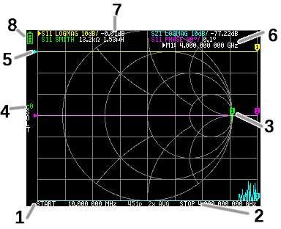

START frequency

STOP frequency
The START frequency and STOP frequency are shown at the bottom of the display. You can quickly select a frequency by clicking on the start or end frequency, and modify the frequency by moving the Jog switch, and click on the frequency again after selecting it to bring up the on-screen keyboard for quick frequency entry. You can set the frequency in more detail through the menu Setting the measurement frequency range.

Marker
The marker position for each trace is displayed as a small numbered triangle. The selected marker can be moved to any of the measured points in the following ways:
  - Drag a marker on the touch panel , the corresponding trace will also be selected.
  - Press and hold the JOG LEFT or JOG RIGHT buttons.

Calibration status
Displays the saved slot number of the calibration being used and the error correction applied. C0 C1…: Each indicates that the corresponding calibration data is loaded.

Reference position
Indicates the reference position of the corresponding trace. You can change the position with:

DISPLAY →SCALE →REFERENCE POSITION.

Marker status
Displays the selected marker points and the frequency of the marker points.

Trace status
The status of each trace format and the value corresponding to the active marker are displayed.
For example, if the display is showing: S11 LOGMAG 10dB/ 0.02dB , read it as follows: Channel S11 (reflection)
Format LOGMAG Scale is 10dB
Current value is 0.02dB
For the selected trace, the channel name is marked with a triangular shape in front.

Battery status
Display the battery voltage, when the icon turns red, please charge as soon as possible, otherwise the battery may enter the protection state, once the battery enters the protection state, you need to charge in the power off state to reactivate the battery.

Menu screen

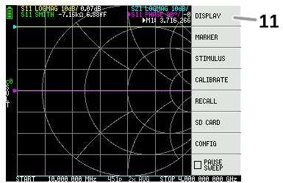

Menu List
The menu can be opened by the following operations:
  - When a location other than a marker on the touch screen is tapped.
  - When the Jog is pressed.

Keypad screen
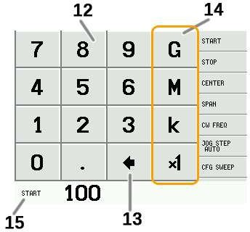

Numeric keys
Tap a number to enter one character.

Back key
Delete one character. If no character is entered, the entry is canceled and the previous state is restored.

Unit key
Multiplies the current input by the appropriate unit and terminates input immediately. In case of
× 1, the entered value is set as it is.

Input field
The name of the item to be entered and the entered number are displayed.

Device settings
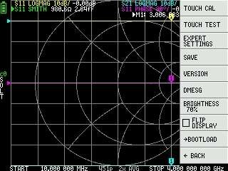
The CONFIG menu contains general settings for the device:

Saving device settings
Select CONFIG →SAVE to save general instrument settings. General device settings are data that includes the following information:
  - Touch screen calibration information
  - Brightness
The CONFIG →SAVE command does not apply to calibration settings.

Display version info
Select CONFIG →VERSION to display device version information.

LCD Brightness adjustment
Select CONFIG→BRIGHTNESS, the brightness adjustment interface will pop up, move the joystick left and right to adjust the brightness, press the joystick to exit the brightness adjustment, save the brightness settings by CONFIG →SAVE.

Firmware update mode
CONFIG→ BOOTLOAD then select RESET AND ENTER to enter the firmware update mode.
You can also press the Jog while powering on to enter the firmware update mode.
Then the firmware update prompt will pop up through NanoVNA-APP connected section.

Touch panel calibration and testing
The LCD touch panel can be calibrated using CONFIG → TOUCH CAL if there is a large difference between the actual on-screen tap position and the recognized tap position.


NOTE: Be sure to save the settings with CONFIG → SAVE.

You can then test the LCD touch panel stylus tracking accuracy by selecting CONFIG → TOUCH TEST.
A line is drawn while dragging the stylus along the touch panel. When released from the touch panel, it returns to its original state. Repeat & save the touch screen calibration if tracking is incorrect.
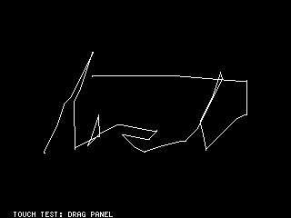

Performing measurements
The basic measurement sequence is:
  - Set the frequency range to be measured.

Use STIMILUS → START/STOP or STIMILUS →CENTER/SPAN
  - Perform calibration (and save!)
  - Connect the Device Under Test (DUT) and measure.
Note: After modifying the frequency, LiteVNA will calculate the calibration parameters by interpolation, and we still recommend that you re-perform the calibration if you need accurate measurements.

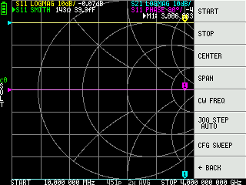
Setting the measurement frequency range
There are three types of measurement range settings.
- Setting the start frequency and stop frequency
- Setting the center frequency and span
- Continuous wave frequency

Setting the start frequency and stop frequency
Select and set STIMULUS → START and STIMULUS → STOP, respectively.

Setting the center frequency and span
Select and set STIMULUS → CENTER and STIMULUS → SPAN, respectively.

Zero span
Zero span is a mode in which one frequency is sent continuously without frequency sweep.
Select and set STIMULUS → CW FREQ.
Note that using a single frequency scan will records the reference signal after the first scan is completed, and the internal RF switch can maintain a continuous signal output, which is useful for some situations where a continuous signal output is required.

Temporarily stop measurement
When menu item PAUSE SWEEP is active, measurement is temporarily stopped.

Calibration
Calibration is required before you can start using it. LiteVNA will calculate the calibration parameters by interpolation after modifying the measurement frequency, but if you change from a narrower frequency to a wider frequency, the interpolation calculation will no longer be accurate. Due to the errors in the interpolation calculation, it is also recommended that you calibrate first for situations where precise measurements are required.
The coaxial cable connected to the device under test should be connected to the LiteVNA port before calibration. Although LiteVNA provides electrical delay compensation and we provide the best coaxial cable possible, to minimize calibration errors, we recommend that you calibrate at the end as close to the device under test as possible.
The calibration procedure is as follows:
- Reset current calibration state. Select menu item CAL →RESET and then

→CALIBRATE.
- Connect OPEN standard to port 1 cable and click →OPEN. Wait for the current calibration step to be completed, and the cursor will automatically move to the next step.
- Connect SHORT standard to port 1 cable and click →SHORT. Wait for the current calibration step to be completed, and the cursor will automatically move to the next step.
- Connect LOAD standard to port 1 cable and click →LOAD. Wait for the current calibration step to be completed, and the cursor will automatically move to the next step.

- Connect LOAD standard to port 1 cable and click →ISOLN. Wait for the current calibration step to be completed, and the cursor will automatically move to the next step.
- Connect the THRU standard between the port 1 and port 2 cable ends, and click
→THRU. Wait for the current calibration step to be completed, and the cursor will automatically move to the next step.
- Click →DONE.
- In the pop-up save menu inside choose the location you need to save, save 0 will be automatically called back in the next boot.

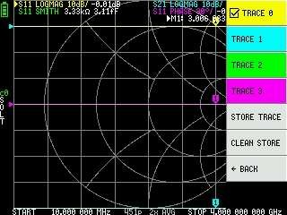
Trace display

Up to four traces can be displayed, one of which is the selected trace.
Click on the menu DISPLAY → TRACES → TRACES n to select a trace, and click again to turn a trace on or off.

The selected trace will be marked with a tick in front of its menu item and with a triangle in front of the trace name in the main screen.

Trace format
Although each trace can have its own displayed format, you can only change the format of the active trace.
To assign a format, set the trace to active (see above) then select: DISPLAY
→FORMAT The description and unit of measurement of each format is as follows:
- LOGMAG : Logarithm of absolute value of measured value (dB per div)
- PHASE : Phase in the range of -180 ° to + 180 ° (90 degree default)
- DELAY : Delay (pico or nano seconds)
- SMITH : Smith Chart (Impedance scale is normalized during calibration)
- SWR : Standing Wave Ratio
- POLAR : Polar coordinate format (Impedance scale is normalized during calibration)
- LINEAR : Absolute value of the measured value
- REAL : Real part of measured S parameter
- IMAG : Imaginary part of measured S parameter
- RESISTANCE : Resistance component of the measured impedance (ohms per div)
REACTANCE : Reactance component of the measured impedance (ohms
- per div)

Trace channel
LiteVNA is a switch-switched T/R VNA that measures S11 (reflection, return loss) and S21 (transmission, insertion loss).
Each trace can be set the measurement channel by clicking on the menu Display →

Channel.

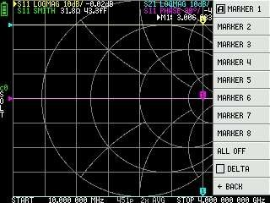
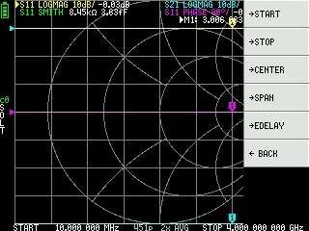
Markers

Up to 8 markers can be displayed.
Markers are selected by the menu items MARKER →SELECT MARKER →MARKER n .
Clicking on a disabled marker menu item enables it and makes it active. Clicking on an enabled but non-active marker activates it. Clicking on the currently active marker disables it.

Setting frequencies from marker(s)
You can set the frequency range from the MARKER →OPERATIONS menu as follows:
- OPERATIONS →START - Sets the start frequency to the active marker’s frequency.
- OPERATIONS →STOP - Sets the stop frequency to the active marker’s frequency.
- OPERATIONS →CENTER - Sets the frequency of the active marker to be the center frequency.
- OPERATIONS →SPAN - Sets the absolute frequency span to the last two active markers. You need to have any two markers (M1-M8) enabled for the Span button to work. If only one marker is displayed, nothing happens.

Time domain operation
The LiteVNA can simulate time domain reflectometry by transforming frequency domain data.
Select DISPLAY →TRANSOFRM →TRANSFORM ON to convert measured data to the time domain.
If TRANSFORM ON is enabled, the measurement data is immediately converted to the time domain and displayed. The relationship between the time domain and the frequency domain is as follows.
- Increasing the maximum frequency increases the time resolution
- The shorter the measurement frequency interval (ie, the lower the maximum frequency), the longer the maximum time length
For this reason, the maximum time length and time resolution are in a trade-off relationship. In other words, the time length is the distance.
- If you want to increase the maximum measurement distance, you need to lower the frequency spacing (frequency span / sweep points).
- If you want to measure the distance accurately, you need to increase the frequency span.
HINT – Use a lower frequency to measure a longer length and a higher frequency to measure a shorter length and adjust accordingly for accurate results.

Time domain bandpass
In bandpass mode, you can simulate the DUT response to an impulse signal.
NOTE: The trace format can be set to LINEAR, LOGMAG or SWR.
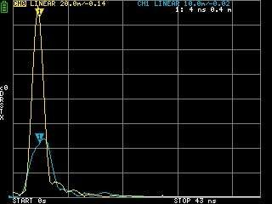
The following is an example of the impulse response of a bandpass filter.

Time domain low pass impulse
In low-pass mode, you can simulate TDR. In low-pass mode, the start frequency must be set to 50 kHz, and the stop frequency must be set according to the distance to be measured.
The trace format can be set to REAL.
Examples of Impulse response in open state and impulse response in short state are shown below.

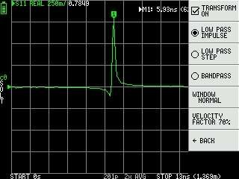
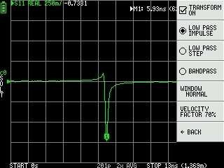
Open Short

Time domain low pass step
The trace format can be set to REAL.
Example measurements of Step response are shown below.

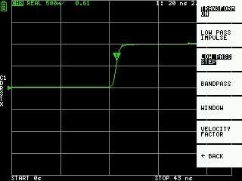
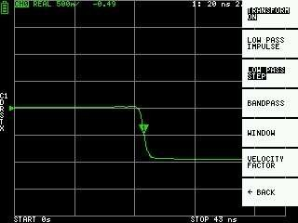
Open Short

Capacitive short Inductive short
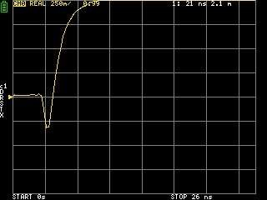
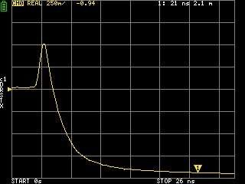

Capacitive discontinuity (C in parallel) Inductive discontinuity (L in series)
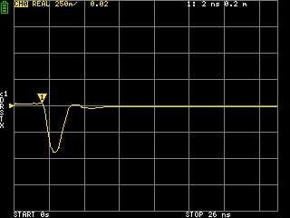
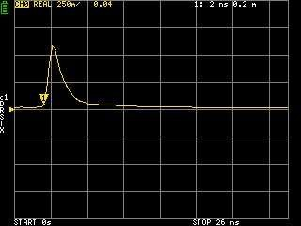

Time domain window
The range that can be measured is a finite number, and there is a minimum frequency and a maximum frequency. A window can be used to smooth out this discontinuous measurement data and reduce ringing.
There are three levels of windowing.
- MINIMUM (no window, ie: same as rectangular window,highest resolution)
- NORMAL (equivalent to Kaiser window = 6β)
- MAXIMUM (equivalent to Kaiser window = 13β, highest dynamic range)

Setting the velocity factor in the time domain
The transmission speed of electromagnetic waves in the cable varies depending on the material. The ratio to the transmission speed of electromagnetic waves in vacuum is called the Velocity Factor. This is always stated in the cable specifications.
In the time domain, the displayed time can be converted into distance. The wavelength shortening ratio used for distance display can be set with DISPLAY → TRANSFORM

→ VELOCITY FACTOR .
For example, if you measure the TDR of a cable with a wavelength reduction rate of 67%, specify 67 for the VELOCITY FACTOR. (Do not use the decimal point).

Recall calibration and settings
Up to 7 calibration datasets can be saved. LiteVNA automatically loads data with recall 0 when it starts.
Calibration data includes the following information:

- Frequency range setting
- Error correction at each measurement point
- Trace settings
- Marker settings
- Domain mode settings
- Electrical delay
You can save the current settings by selecting CAL → SAVE → SAVE n. Current calibration data can be reset by selecting CAL → RESET.
CAL → CORRECTION indicates whether error correction is currently enabled. You can deselect this to temporarily disable error correction.
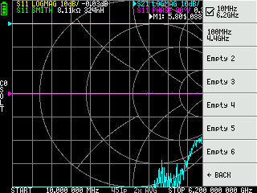

Saving measurement data with a MicroSD card
You can use a MicroSD card to save measurement data in SNP format or to save screenshots in BMP format. MicroSD card uses SPI mode and only supports smaller than 32GB and formatted with FAT or FAT32.
Click on SD CARD in the main menu to open the Save menu..

NanoVNA-APP Software
The current version of LiteVNA uses the same communication protocol as SAA2 to ensure good compatibility with NanoVNA-APP.

User interface
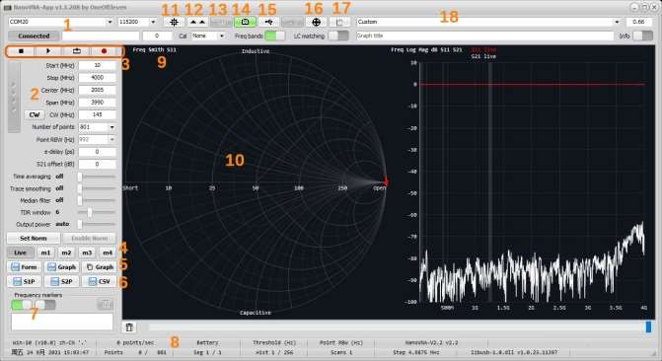

COM port
Select the COM port to connect LiteVNA. When the connection status shows Connected, it means LiteVNA is connected, click Connected to disconnect, click Disconnected to reconnect. The serial port baud rate does not work when connecting via USB port.

Stimulus setting area
Used to set scanning parameters, including scanning frequency, scanning points, etc.

Scanning control
Click to stop scanning, click single scan, click for continuous scanning, click to automatically record S2P files after each scan is completed.

Trace setting
In addition to displaying real-time scanned traces, you can also display multiple stored traces and right-click the corresponding button to import the SNP file you need to display.

Save image
Click to save the current window or the current trace display window, or to copy the trace window to the clipboard.

Export Data
Click to export the data in SNP or CSV format.

Marker point data
To display the marker point data, you can add or remove marker points by double- clicking the left mouse button in the right trace window or by clicking the right mouse button in the trace window and the pop-up menu appears.

Status Bar
Shows some settings and working status.

Trace format
Show the current trace format, click to select the trace format.

Trace window
Show the trace, right mouse click can pop up the trace setting menu. Roll the mouse wheel in the upper part of the left axis or hold down the left button to drag to modify the maximum value of the axis, roll the mouse wheel in the middle of the left axis to modify the scale of the axis, hold down the left button in the middle of the left axis to drag to move the axis as a whole, and roll the mouse wheel in the lower part of the left axis or hold down the left button to drag to modify the minimum value of the axis。

Settings button
Click to open the settings window.

Update firmware
LiteVNA determines whether it needs to enter update mode through the communication protocol, the button does not work when LiteVNA is connected. If you need to update the firmware of LiteVNA, you need to press and hold the rocker switch of LiteVNA, then turn on the power, LiteVNA will enter the update mode, the screen will remain black, then connect through NanoVNA-APP, the update firmware prompt will pop up, click "Yes" to enter the firmware update interface.

Battery Status
The current LiteVNA communication protocol does not support passing battery information at this time.

Screenshot button
Click to capture LiteVNA's screen image.

Communication Monitoring
Click to open the communication monitoring window, you can view or send some debugging information

Calibration Button
Click to open the calibration interface, the calibration process is similar to calibrating directly with LiteVNA, and you can save the calibration data after the calibration is completed. You can also load the calibration data. Note that if you need to use the calibration of NanoVNA-APP, it is recommended that you reset the calibration on LiteVNA first in order to ensure the
measurement accuracy.

Separate trace window
Click to bring up a separate trace window, and you can create multiple separate trace windows.

Time domain velocity factor
Used to set the TDR velocity factor, some common cable factors are built in and can be selected via the drop-down menu.

Use Zadig to install the USB-CDC driver.
Windows 10 and above operating systems can automatically recognize USB-CDC devices, so connecting LiteVNA on windows 10 and above operating systems can automatically recognize COM ports.
If you are using an older windows system, or if LiteVNA is recognized as the wrong device, you can use Zadig to install the driver.

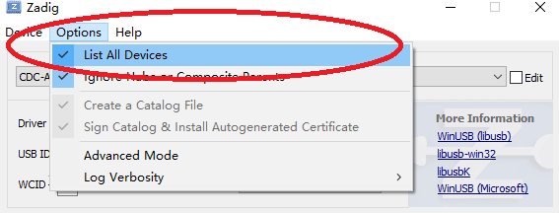
In Zadig's Options menu, enable List All Devices.

Select CDC-ACM Demo in the drop-down box of the device list.

Select USB Serial (CDC) inside the driver selection box.

Click Replace Driver (or Install Driver) to install the driver.
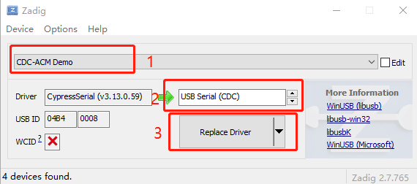

Check in the Device Manager if the COM port is already displayed.

Appendix– USB data interface
To ensure compatibility with current PC software, LiteVNA uses the same data communication protocol as SAA2, appears as a USB CDC (Communications Device Class) virtual serial port both during normal operation and in DFU mode. PC software can issue commands and request data by sending and receiving data on the virtual serial port. Communications protocol is identical in the two cases, with only register layouts differing.

Protocol description
Only the host may initiate commands by sending one or more bytes on the virtual serial port. Each command may have a different length. There is no separator delimiting each command. The device may not send data to the host except for replies to a host-to-device command.
The following table lists all supported commands and their byte encodings, and is applicable both during normal operation and in DFU mode.

Host to device command list
All byte values in the table are in hexadecimal. B0 to B5 denote bytes 0 to 5. B0 is the opcode.
B0 | B1 | B2 | B3 | B4 | B5 | Name | Description
00 | - | - | - | - | - | NOP | No operation
0d | - | - | - | - | - | INDICATE | Device always replies with ascii ‘2’ (0x32)
10 | (AA) | - | - | - | - | READ | Read a 1-byte register at address AA. Reply is one byte, the read value.
11 | (AA) | - | - | - | - | READ2 | Read a 2-byte register at address AA. Reply is 2 bytes, the read value.
12 | (AA) | - | - | - | - | READ4 | Read a 4-byte register at address AA. Reply is 4 bytes, the read value.
18 | (AA) | (NN) | - | - | - | READFIFO | Read NN values from a FIFO at address AA. Reply is the read values in order.  Each value can be more than one byte and is determined by the FIFO being read.
20 | (AA) | (XX) | - | - | - | WRITE | Write XX to a 1-byte register at address AA. There is no reply.
21 | (AA) | (X0) | (X1) | - | - | WRITE2 | Write X0 to AA, then X1 to AA+1. There is no reply.
22 | (AA) | (X0) | (X1) | (X2) | (X3) | WRITE4 | Write X0..X3 to registers starting at AA. There is no reply.
23 | (AA) | (X0) | (X1) | (X2) | ... | WRITE8 | This command is 10 bytes in total. Bytes 2..9 correspond to X0..X7.  Write X0..X7 to registers starting at AA. There is no reply.
28 | (AA) | (NN) | … |  |  | WRITEFIFO | Write NN bytes into a FIFO at address AA. NN bytes of data to be written into the FIFO should follow “NN”.  There is no reply.

Register descriptions
The following table lists all registers accessible during normal operation. All addresses are in hexadecimal.
Multi-byte integer registers are encoded in Little Endian. Lowest numbered registers contain the least significant portions of the integer.
Address | Name | Description
00..07 | sweepStartHz | Sets the sweep start frequency in Hz. uint64.
10..17 | sweepStepHz | Sets the sweep step frequency in Hz. uint64.
20..21 | sweepPoints | Sets the number of sweep frequency points. uint16.
22..23 | valuesPerFrequency | Sets the number of data points to output for each frequency.  uint16.
26 | rawSamplesMode | Writing 1 switches USB data format to raw samples mode and leaves this protocol.
30 | valuesFIFO | Returns VNA sweep data points. Each value is 32 bytes. Writing any value (using WRITE command) clears the FIFO. See FIFO data format section below.
40 | Average | Set the average multiplier (FFT sample point multiplier, which actually changes the IFBW). Allowable range 1-80 (0x01- 0x50).
41 | LowFrequencyPower | Set the power of the low frequency signal generator (MS5351), default value 0x01, setting range 0x01-0x03.
42 | HighFrequencyPower | Set the power of the High frequency signal generator (MAX2871), default value 0x03, setting range 0x01-0x03.
44 | ChannelSelect | Select the channel to scan, single channel scanning is faster, the closed channel returns invalid values.  0x01 S11, 0x02 S21, 0x00 S11 and S21
58 | UnixTime | Set the system time for liteVNA. Use 4 bytes to send Unix Timestamp.
f0 | deviceVariant | The type of device this is. Always 0x02 for liteVNA.
f1 | protocolVersion | Version of this wire protocol. Always 0x01.
f2 | hardwareRevision | Hardware revision.
f3 | firmwareMajor | Firmware major version.
f4 | firmwareMinor | Firmware minor version.

Remarks sweepStartHz, sweepStepHz, and sweepPoints together set the sweep parameters of the VNA.
Writing any value to these registers will immediately terminate the on-device UI and put the device in “USB data mode”, where the PC has full control over VNA operation.
You can not observe user entered sweep parameters (from the device UI) by reading these registers.
Sweep is always running and can not be paused.

FIFO data format
The values read from valuesFIFO are 32 bytes each. The following table lists the fields in each value. All byte offsets are in hexadecimal. All multi-byte integers are encoded in Little Endian. Lowest numbered bytes contain the least significant portions of the integer.
Bytes | Name | Description | Type
00..03 | fwd0Re | Real part of channel 0 outgoing wave. | int32
04..07 | fwd0Im | Imaginary part of channel 0 outgoing wave. | int32
08..0b | rev0Re | Real part of channel 0 incoming wave. | int32
0c..0f | rev0Im | Imaginary part of channel 0 incoming wave. | int32
10..13 | rev1Re | Real part of channel 1 incoming wave. | int32
14..17 | rev1Im | Imaginary part of channel 1 incoming wave. | int32
18..19 | freqIndex | Frequency index, 0 to sweepPoints - 1. | uint16
1a..1f | (reserved) | (reserved) | -
valuesFIFO is continuously being filled with new sweep data regardless of whether it is being read.
If you wish to do on-demand sweeps, it is necessary to clear stale data before reading from the FIFO. The FIFO can be cleared by writing (with the WRITE command) any value to the FIFO address.
valuesFIFO returns raw values representing the in-phase and quadrature part of the measured waves, which never have user calibration applied. You can not access the on-device user calibrations or calibrated data over USB.
fwd0Re/fwd0Im is referred to as the reference channel. All complex values read from
valuesFIFO can be at a random phase, so you must divide (using complex division) each value by the reference channel to get absolute phase and magnitude values.

Register descriptions (DFU mode)
The following table lists all registers accessible in DFU mode. All addresses are in hexadecimal.
Multi-byte integer registers are encoded in Little Endian. Lowest numbered registers contain the least significant portions of the integer.
Address | Name | Description
e0..e3 | flashWriteStart | Current flash write address. uint32.  Set this to the address to start writing at.
e4 | flashFIFO | Writing to this FIFO will write data into flash starting at  flashWriteStart. flashWriteStart will be incremented by the number of bytes written.
e8..eb | userArgument | The user argument to pass to the program upon soft reset.  uint32.
ef | doReboot | Write 0x5e to initiate a soft reset.
f0 | deviceVariant | The type of device this is. Always 0x02 for LiteVNA.
f1 | protocolVersion | Version of this wire protocol. Always 0x01.
f2 | hardwareRevision | Hardware revision. Always 0x00 in DFU mode.
f3 | firmwareMajor | Firmware major version. Always 0xff in DFU mode.
f4 | firmwareMinor | Firmware minor version (of the bootloader).

Writing to flash
The procedure to write a new firmware image to flash are as follows.
  - Connect the device to the PC over USB and put the device into DFU mode.
  - Open the virtual serial port in raw mode (platform specific).
  - Write the address you wish to start flashing from to flashWriteStart.
  - Use the WRITEFIFO command to send up to 255 bytes at a time to flashFIFO. Each WRITEFIFO command can be followed with a INDICATE command, which will reply with ‘2’ only after the flash operation is complete.
There is no flow control on the virtual serial port and you must limit the amount of outstanding writes to no more than 2048 bytes.
  - (Optional) Write 0x5e to doReboot to soft reset the device.

